**AMKmotion’s ihD servo inverter for dynamic drive solutions in machinery and systems**

**Efficient, flexible and space-saving – AMKmotion’s new ihD servo inverter sets new standards in decentralized drive technology. With its innovative single-cable daisy chain concept and a 300-degree rotatable plug for motor and encoder connections, it significantly reduces installation effort and enables economical, compact machine designs.**

AMKmotion’s ihD servo inverter stands out with its minimal space requirements and well-designed cabling: power, STO (Safe Torque Off), 24V, and fieldbus communication are transmitted via a single cable. Thanks to the daisy chain method, multiple servo inverters can easily be connected in series, reducing cabling costs by up to 70% compared to centralized drive systems.

Another key benefit: in the ihD-DT5 version, the inverter is mounted directly on the motor series, with the control electronics already integrated in the motor. This not only eliminates the need for external cabling, it also significantly simplifies installation.

**Extremely high-performance electronics in a smart design**

The ihD delivers powerful, dynamic performance even under demanding conditions: At a rated current of eight amps, it can provide triple overload for one second – ideal for applications with dynamic load peaks and high cycle rates.

One particular standout feature of the ihD is its flexible connection concept: depending on the installation setup, the hybrid input connector can face either backward or upward. In the stand-alone version of the ihD, a 300-degree rotatable plug is also available for motor and encoder connections. This makes integration into existing machine concepts much easier, saving both space and cabling.

The ihD is also impressive due to its intelligent energy management: excess energy is distributed to all connected servo inverters via a shared DC bus, thereby reducing losses and increasing overall system efficiency.

With protection class IP65, the ihD is ideally suited to demanding industrial environments – unaffected by dust, moisture, or vibrations.

**Compact and flexible**

At just 165 × 100 × 60 millimeters, the ihD is extremely compact for its power class and offers the smallest volume on the market in its category. This enables even more space-saving decentralized drive solutions – a major advantage where installation space is limited. The combination of hybrid cabling, flexible connection options, compact design and robust construction makes the ihD an ideal solution for scalable, flexible drive systems.

Another key benefit: the ihD is entirely plug-in compatible. There is no need to open the inverter for connection, and when the system is de-energized, installation can be carried out without requiring specialized personnel.

The ihD is available as a stand-alone version or in combination with AMKmotion motor series, ensuring maximum flexibility in terms of drive system design. The ability to power it either on a decentralized basis or from the switch cabinet adds even more adaptability for a wide range of machine concepts.

***Service for editorial departments:***

***Meta Title:*** *ihD by AMKmotion: decentralized servo inverters with hybrid cable connection*

***Meta Description:*** *With its innovative hybrid cabling concept, AMKmotion’s ihD servo inverter is extremely compact for its performance class and significantly reduces installation effort.*

***Social media:*** *Thanks to its hybrid single-cable daisy chain concept, the decentralized ihD servo inverter transmits power, fieldbus communication, and STO via a single cable – reducing wiring effort and cutting costs. Triple overload capacity, flexible connection design and a compact form with a 300-degree rotatable plug for motor and encoder connections make it a space-saving and versatile solution.*

**Caption**

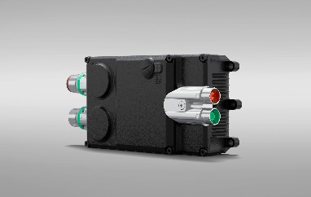

**Image 1:** With its innovative hybrid cabling concept and 300-degree rotatable plug for motor and encoder connections, AMKmotion’s new ihD servo inverter significantly reduces installation effort.

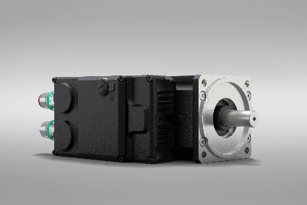

**Image 2:** The ihD-DT5 combines the inverter and motor in a compact unit, further reducing wiring needs.

**Image credits:** AMKmotion GmbH + Co KG

**About AMKmotion**

AMKmotion specialises in the development and manufacture of electric drive systems and sees itself as a long-term partner in the field of industrial mechanical engineering and plant engineering. The company’s aim is to help its customers achieve technological leadership by integrating individual and sustainable solutions.

The basis for this is AMKmotion’s hands-on mentality, combined with expertise acquired in more than 60 years of company history. We attach particular importance to personal advice and trusting cooperation with customers.

The company was founded in 1963 as AMK Arnold Müller GmbH & Co. KG. It has belonged to the Arburg family since 2021 and has operated under the name AMKmotion GmbH + Co KG since then. The portfolio includes electric drive technology, control technology and industrial automation technology. AMKmotion has a total workforce of 500 people. In addition to its headquarters in Kirchheim unter Teck, AMKmotion has production sites in Weida (Thuringia) and in Gabrovo, Bulgaria, as well as twelve branch offices around the world.

**Contact**

AMKmotion GmbH + Co KG

Anja Schaber

Marketing Manager

Gaußstraße 37-39

73230 Kirchheim unter Teck

Germany

[www.amk-motion.com](http://www.amk-motion.com)

[anja.schaber@amk-motion.com](mailto:anja.schaber@amk-motion.com)

Phone +49 7021 5005 373

Mobile +49 152 5305 5372