**Everything from a single source: AMKmotion showcases drive solutions up to 500 amps**

**Anything but off the shelf – at SPS 2025 (November 25–27, Nuremberg) AMKmotion will demonstrate in Booth 210, Hall 4, how even very individual customer requirements can be implemented in customized system solutions. Users get everything from a single source, enabling them to reduce their overall costs.**

“We offer standard solutions too, of course – but in a lot of the projects we’re involved with, things get very demanding,” says Alexander Hipp, Director Sales & Customer Solution Center at AMKmotion. Just how flexibly the manufacturer of electric drive systems is able to respond will be shown in Nuremberg.

In Booth 210, Hall 4, AMKmotion will demonstrate servo motors with high levels of power density and efficiency. They can be precisely adapted based on their winding and frame size, for example. The portfolio also includes motion controllers for precise axis synchronization. With a current range from 1 to 500 amps, AMKmotion covers the entire spectrum of drive tasks. Users always get the perfect solution – never oversized – and this has a positive impact on costs.

AMKmotion offers both central and decentralized drive solutions – and also combines both approaches to create hybrid systems. This increases energy efficiency and flexibility, simplifies cabling and creates space in the switch cabinet.

**Focus on new products**  
  
Trade fair highlights include new and refined solutions – among them the ihD, a decentralized servo inverter with single-cable wiring for daisy-chain connection: power, STO (Safe Torque Off), 24 volts and communication all run through a single cable, reducing wiring costs by up to 70 percent compared to centralized concepts. With the control electronics built into the motor, the ihD-DT5 is easier than ever to set up. In recognition of this concept, the servo inverter came first in the drive technology category of the 2025 “Product of the Year” competition run by *Industrial Production* and *Kunststoff Magazin*.

In addition to this there is the KE/KW system: the compact power supply (KE) generates the DC bus voltage and powers the compact inverter (KW). The hybrid distributor (KHY) bundles signals and supply voltages from the central level and acts as an interface to the decentralized domain. New to the lineup are the K2W and K4W inverters, rounding out the series at the top end. The result is a compact multi-axis system that delivers more power in the smallest possible footprint. The K4W requires just a single device interface for up to four axes, saving both material and space in the switch cabinet. Additional axes can be integrated seamlessly.

At SPS, AMKmotion will also be presenting a new and particularly innovative generation of synchronous servo motors. The DIP is a powerhouse that offers impressive dynamic response and power density – taking drive technology to the next level.

**Components in action**  
Visitors will be able to experience the solutions live in action at the booth. With its electric marble run, AMKmotion shows how the hybrid components mesh to create compact and flexible automation solutions – often without the need for a switch cabinet. A swivel unit from body-in-white manufacturing will also demonstrate at SPS how workflows in factory automation can be accelerated and simplified. Here, processes such as gripping, punching, and welding demand maximum dynamic response within the most confined spaces. In order to make this happen, the inverter is mounted directly on the motor. In combination with a decentralized power supply, an integrated motion controller, and a synchronous servo motor, this creates a compact mechatronic unit that reduces wiring and saves space in the switch cabinet – a key advantage when it comes to efficiency and flexibility.

All AMKmotion products are developed in line with the requirements of the Cyber Resilience Act.

**AI for smarter drives**  
Artificial intelligence is a key factor at AMKmotion, too. Combined with mechatronic expertise and mathematical modeling, it forms the basis for smart solutions in converter control technology (closed loop). Alongside classic analysis methods, more and more AI-driven features are being integrated into the products – with the aim of improving the user experience, for instance.

One example is the front end for the AIPEX engineering tool: this will help users identify problems more quickly and enable them to have solutions displayed straight away. AIPEX 5 is a fully web-based, platform-independent tool for efficient configuration, parameterization, and diagnosis of AMKmotion products, enabling production processes to be set up more quickly, reducing operating costs and boosting efficiency in the long term.

**AMKmotion at SPS: Hall 4, Booth 210**

***Service for editorial departments:***

***Meta-Title:*** *AMKmotion will be showcasing drive solutions up to 500 amps at SPS 2025*

***Meta Description:*** *At SPS 2025, AMKmotion will be presenting new drive solutions – from servo motors up to 500 A to cabinet-free concepts for factory automation.*

***Social media:*** *Everything from a single source: at SPS 2025, AMKmotion will be showcasing drive solutions that deliver maximum flexibility, efficiency, and dynamic response – from servo motors up to 500 amps to compact multi-axis systems and cabinet-free concepts for factory automation. In the spotlight: the award-winning decentralized servo inverter ihD and the new DIP generation of motors.*

**Captions**

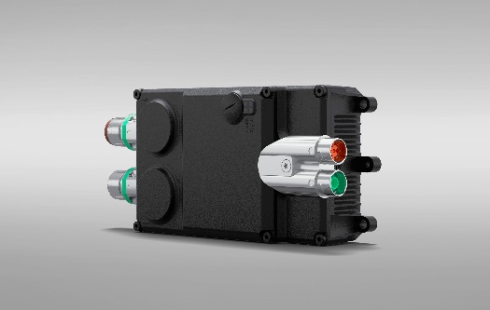  
**Image 1:** With its innovative hybrid cabling concept and 300-degree rotatable plug for motor and encoder connections, AMKmotion’s new ihD servo inverter significantly simplifies installation.

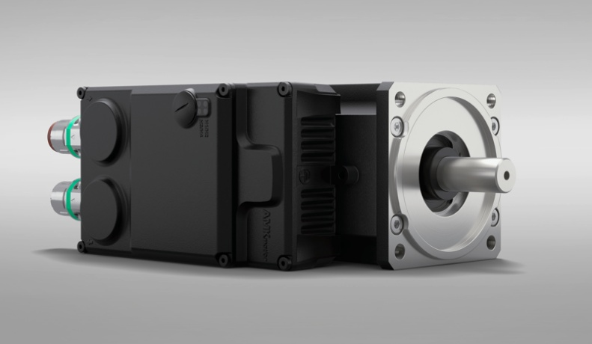  
**Image 2:** The ihD-DT5 combines the inverter and motor in a compact unit, further reducing wiring complexity.

**Ein Bild, das Text, Screenshot, Design, Batterie enthält.
**

**Image 3:** The KE/KW servo drive system – AMKmotion has now rounded out this product family at the top end.

Ein Bild, das Text, Screenshot, Computer, Spielzeug enthält.
**Image 4:** The engineering tool AIPEX 5 enables the user to configure, parameterize and diagnose applications.

**Image credits:** AMKmotion GmbH + Co KG

**About AMKmotion**

AMKmotion specialises in the development and manufacture of electric drive systems and sees itself as a long-term partner in the field of industrial mechanical engineering and plant engineering. The company’s aim is to help its customers achieve technological leadership by integrating individual and sustainable solutions.

The basis for this is AMKmotion’s hands-on mentality, combined with expertise acquired in more than 60 years of company history. We attach particular importance to personal advice and trusting cooperation with customers.

The company was founded in 1963 as AMK Arnold Müller GmbH & Co. KG. It has belonged to the Arburg family since 2021 and has operated under the name AMKmotion GmbH + Co KG since then. The portfolio includes electric drive technology, control technology and industrial automation technology. AMKmotion has a total workforce of 500 people. In addition to its headquarters in Kirchheim unter Teck, AMKmotion has production sites in Weida (Thuringia) and in Gabrovo, Bulgaria, as well as twelve branch offices around the world.

**Contact**

AMKmotion GmbH + Co KG

Anja Schaber

Marketing Manager

Gaußstraße 37-39

73230 Kirchheim unter Teck

Germany

[www.amk-motion.com](http://www.amk-motion.com)

[anja.schaber@amk-motion.com](mailto:anja.schaber@amk-motion.com)

Phone +49 7021 5005 373

Mobile +49 152 5305 5372