New synchronous servo motor DIP from AMKmotion: compact, dynamic, and resource-efficient
AMKmotion is now launching its new DIP series – a next-generation line of synchronous servo motors. Delivering up to three times the acceleration of comparable drives, they combine exceptionally high power density with a compact footprint. The integrated reluctance torque component significantly reduces the use of rare-earth materials.
“In developing the DIP we’ve created a true all-rounder,” says Marc Scheer, Head of Inside Sales at AMKmotion. "Our goal was to design an energy-efficient synchronous servo motor that offers high power density, outstanding dynamics, and requires considerably less current at the same acceleration than comparable models.” Users benefit from shorter process cycles and higher productivity. Since less energy is required for axis movement, overall current consumption is reduced. This directly impacts design: machines can be built more compactly and operated more efficiently because oversized cooling systems and large safety clearances are no longer necessary.
More torque, fewer magnets
By means of an optimized magnetic circuit, AMKmotion has reduced the rotor inertia to one-third that of comparable drives. "This allows the new synchronous servo motors to respond more quickly to setpoint changes and be controlled with greater precision," explains Benjamin Abdic, Product Manager Motors at AMKmotion. “The result is systems that operate with greater accuracy and consistently maintain top product quality.” The reluctance torque component contributes additional torque without requiring extra magnetic material, significantly reducing the use of rare-earth elements.
At the same time, the DIP achieves up to three times the acceleration of comparable synchronous servo motors such as AMKmotion’s DT10. “With its exceptional torque and high rotational speed, the DIP delivers more power and velocity in the smallest possible space,” Abdic adds. The outcome: shorter process cycles, lower energy costs, and higher productivity.
Shorter cycle times, greater precision
The new synchronous servo motors are designed for applications such as the printing and packaging industries – in punching and cutting systems, conveyors, and filling or wrapping machines, for instance. In these settings, the DIP shortens cycle times and ensures highly repeatable motion sequences. It enables fast, precise load changes in test benches and measurement systems such as those used for dynamic load simulations or torque control, while in plastics industry, the motor shortens cycle times and increases injection speeds in applications such as injection moulding, thermoforming, and film drawing machines. “This allows manufacturers to produce even delicate components with greater precision,” says Scheer.
Flexible configuration
Like all AMKmotion servo motors, the DIP series can be precisely tailored to customer requirements by selecting the appropriate winding and frame size options, enabling it to be seamlessly integrated in the AMKmotion system architecture. “With our modular system components we’re able to deliver fully customized solutions,” says Abdic.
The current product range covers size 10 motors with power ratings from 5 to 100 kW. Additional frame sizes, lengths, and design variants will follow, along with cooling options such as convection, liquid, or forced-air cooling. “With its outstanding dynamic response and power density, the DIP sets a new benchmark in drive technology,” Scheer concludes.

Service for editorial departments:
Meta-Title: AMKmotion’s new synchronous servo motor DIP: compact and dynamic
Meta Description: AMKmotion presents the new synchronous servo motor DIP – offering high power density, compact construction, up to three times the acceleration, and reduced use of rare-earth elements.
Social media: Compact, dynamic, and resource-efficient: the new synchronous servo motor DIP sets new standards in drive technology. A compact powerhouse, it achieves three times the acceleration of comparable drives in its size class, while the reluctance torque component reduces the use of rare-earth materials. Users also benefit from shorter cycle times and increased productivity.

Caption
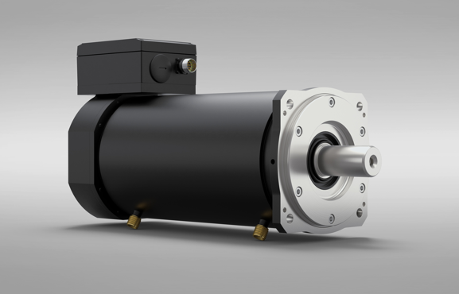
Image 1: The new synchronous servo motor in the DIP series: a compact powerhouse, it achieves three times the acceleration of comparable drives in its size class.

Image credits: AMKmotion GmbH + Co KG

About AMKmotion
AMKmotion specialises in the development and manufacture of electric drive systems and sees itself as a long-term partner in the field of industrial mechanical engineering and plant engineering. The company’s aim is to help its customers achieve technological leadership by integrating individual and sustainable solutions.
The basis for this is AMKmotion’s hands-on mentality, combined with expertise acquired in more than 60 years of company history. We attach particular importance to personal advice and trusting cooperation with customers.
The company was founded in 1963 as AMK Arnold Müller GmbH & Co. KG. It has belonged to the Arburg family since 2021 and has operated under the name AMKmotion GmbH + Co KG since then. The portfolio includes electric drive technology, control technology and industrial automation technology. AMKmotion has a total workforce of 500 people. In addition to its headquarters in Kirchheim unter Teck, AMKmotion has production sites in Weida (Thuringia) and in Gabrovo, Bulgaria, as well as twelve branch offices around the world.

Contact
AMKmotion GmbH + Co KG
Anja Schaber
Marketing Manager
Gaußstraße 37-39
73230 Kirchheim unter Teck
Germany
www.amk-motion.com
anja.schaber@amk-motion.com
Phone +49 7021 5005 373
Mobile +49 152 5305 5372

